LAB Manual

PART A

(PART A : TO BE REFERRED BY STUDENTS)

**Experiment No.04**

**A.1 Aim:**

Create a project feasibility report by covering the following points.

* Technical Feasibility – Can we built it
* Economic feasibility – Should we build it.
* Organizational Feasibility - Is the project strategically aligned with the business?

**A.2 Prerequisite:**

Understanding of Technical, Economical and organizational Feasibility.

**A.3 Outcome:**

**After successful completion of this experiment students will be able to:**

Create a project feasibility report by covering following points.

* Technical Feasibility – Can we built it
* Economic feasibility – Should we build it.
* Organizational Feasibility - Is the project strategically aligned with the business?

**A.4 Theory:**

**Steps for conducting Economical Feasibility**

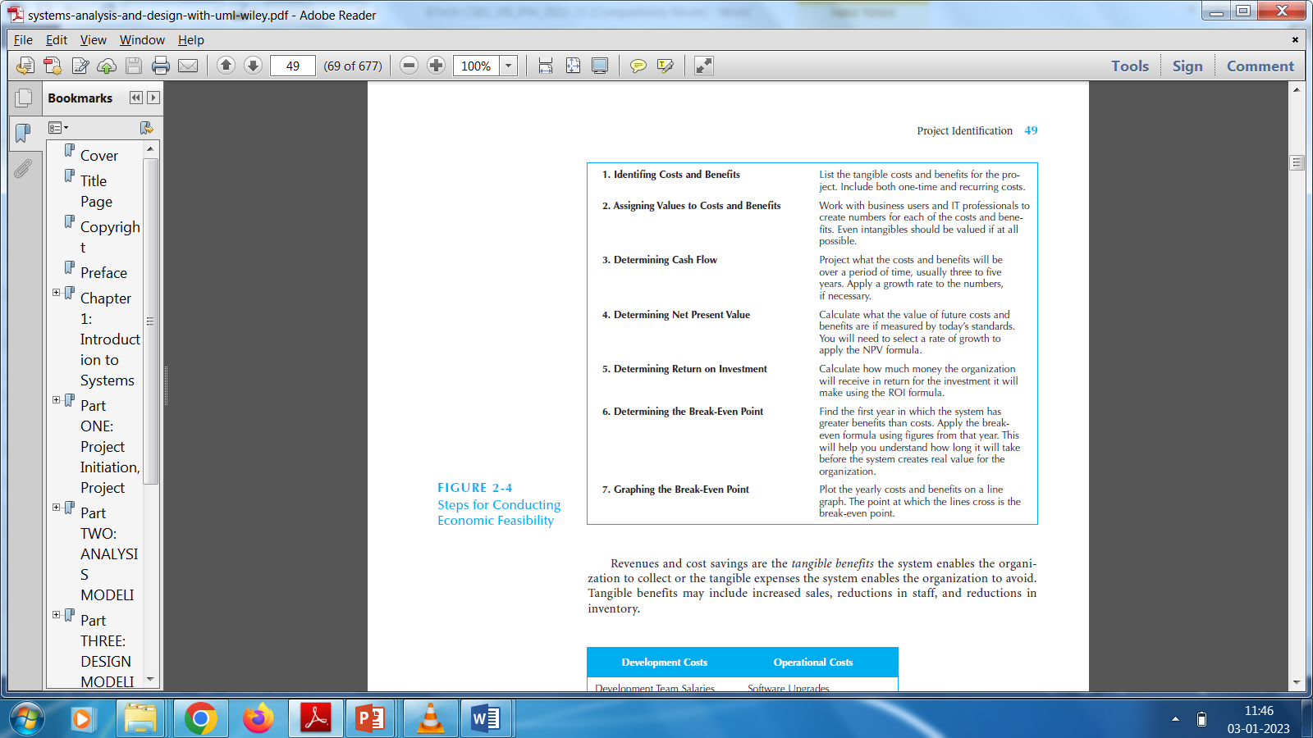

**A.5 Procedure/Algorithm:**

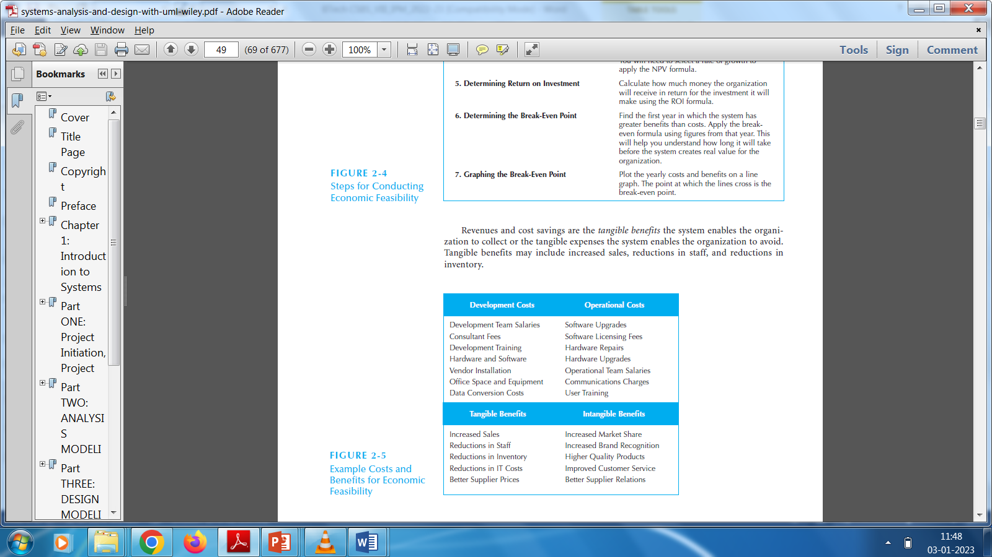

PART B

(PART B : TO BE COMPLETED BY STUDENTS)

***(Students must submit the soft copy as per following segments within two hours of the practical. The soft copy must be uploaded on the Blackboard or emailed to the concerned lab in charge faculties at the end of the practical in case there is no Black board access available)***

| Roll No. | Name: |
| --- | --- |
| Class : | Batch : |
| Date of Experiment: | Date of Submission |
| Grade : |  |

**B.1 Answers of Task to be written by student:**

***(Paste your answers completed during the 2 hours of practical in the lab here)***

**B.2 Observations and learning:**

***(Students are expected to comment on the output obtained with clear observations and learning for each task/ sub part assigned)***

**B.3 Conclusion:**

*(****Students must write the conclusion as per the attainment of individual outcome listed above and learning/observation noted in section B.3)***